Dimmable Bulb

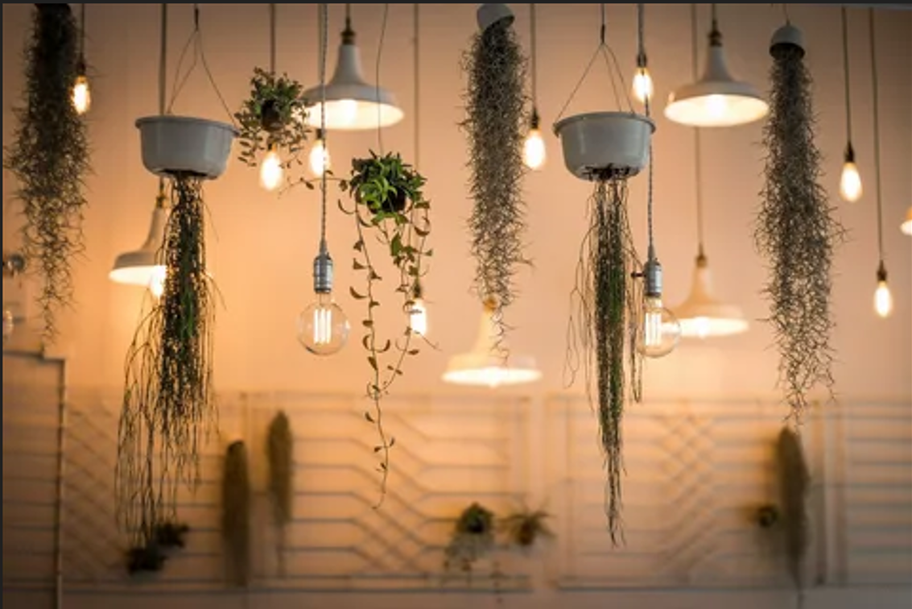

#### ****Description:****

**Dimmable Bulbs** are versatile, energy-efficient lighting solutions that allow you to adjust the brightness to create the perfect ambiance for any occasion. These bulbs are perfect for living rooms, bedrooms, dining areas, and more, where adjustable lighting is essential. With features like dimming and compatibility with standard dimmer switches, Dimmable Bulbs offer a convenient and customizable lighting experience.

* **Technology:** LED or incandescent (depending on the model).
* **Compatibility:** Standard E26/E27 base (fits most fixtures).
* **Bulb Type:** A19 (standard bulb shape), PAR38 (floodlight shape).
* **Wattage:** 9W (LED, equivalent to 60W incandescent), 60W (incandescent).
* **Lumens:** 800 lumens (LED), 800 lumens (incandescent).
* **Color Temperature:** 2700K (warm white), 3000K (soft white), 5000K (daylight).
* **Dimmable:** Yes (compatible with standard dimmer switches).
* **Lifespan:** 25,000 hours (LED), 1,000 hours (incandescent).
* **Energy Efficiency:** LED models are Energy Star certified.

#### ****Key Features:****

* **Adjustable Brightness:** Create the perfect ambiance by adjusting the light level.
* **Energy-Efficient (LED Models):** Uses up to 85% less energy than traditional incandescent bulbs.
* **Warm and Inviting:** Available in warm white (2700K) for a cozy atmosphere.
* **Long Lifespan (LED Models):** Lasts up to 25,000 hours, reducing the need for frequent replacements.
* **Compatibility:** Works with most standard dimmer switches.
* **Versatile Use:** Suitable for living rooms, bedrooms, dining areas, and more.

#### ****Pricing:****

* **Single Bulb (LED, A19):** $12.99
* **Single Bulb (Incandescent, A19):** $7.99
* **4-Pack (LED, A19):** 44.99(44.99(11.25 per bulb)
* **4-Pack (Incandescent, A19):** 29.99(29.99(7.50 per bulb)

#### ****Where to Use:****

* **Living Rooms:** Adjust brightness for movie nights or gatherings.
* **Bedrooms:** Create a relaxing atmosphere with soft, dimmed light.
* **Dining Areas:** Set the mood for meals with adjustable lighting.
* **Home Offices:** Enhance focus with bright light or reduce glare with dimmed light.
* **Hallways:** Provide consistent and energy-efficient lighting.

### ****Customer Reviews:****

* ⭐⭐⭐⭐⭐ "These Dimmable Bulbs are fantastic! They work perfectly with my existing dimmer switch, and the light is so warm and inviting." – Sarah L.
* ⭐⭐⭐⭐ "Great value for the price. The bulbs are bright, and the dimming feature is smooth and reliable." – James T.
* ⭐⭐⭐⭐⭐ "I love how energy-efficient the LED models are. The dimming feature is a game-changer for my living room." – Emily R.

### ****How to Order:****

1. Visit our website: [www.brightworldlighting.com](http://www.brightworldlighting.com/)
2. Select your preferred bulb type and pack size (Single or 4-Pack).
3. Add to cart and proceed to checkout.
4. Enjoy free shipping on all orders over $50!

### ****Warranty and Support:****

* **Warranty:** 2-year limited warranty covering manufacturing defects (LED models).
* **Customer Support:** Contact us at [support@brightworldlighting.com](mailto:support@brightworldlighting.com) or call +1-800-123-4567 for assistance.